Day 1- 16th July 2026

Task 1:
What is Git?

9.48 to 9.50

Task 2:
What is Git Hub?

9.51 to 9.53

Task 3:
What is the difference between Git and Git Hub?

9.54 to 9.59

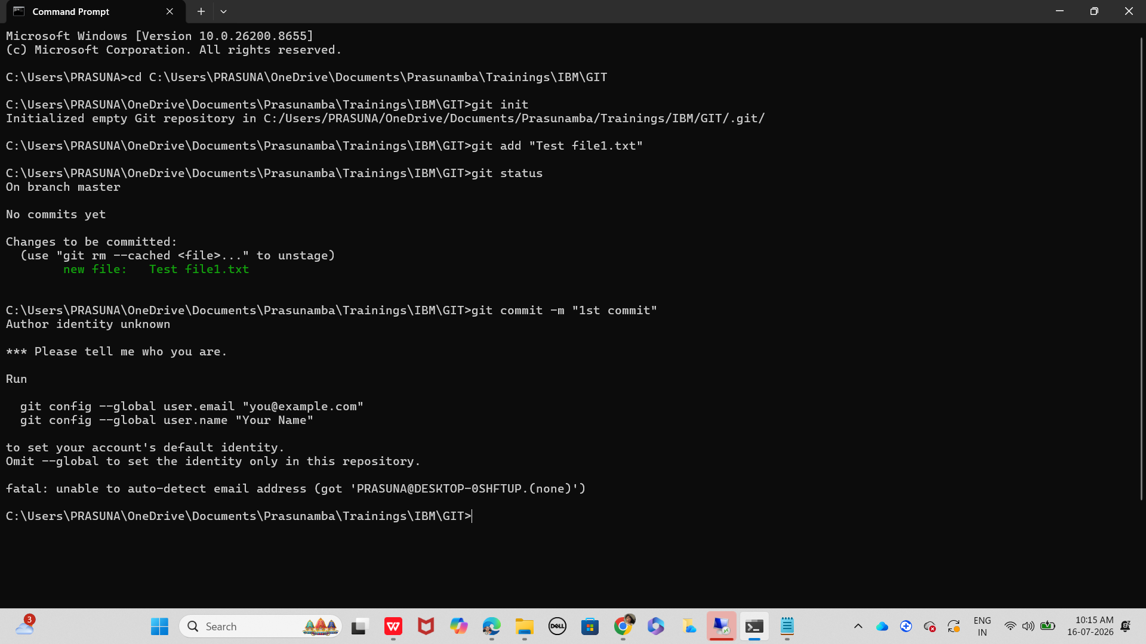

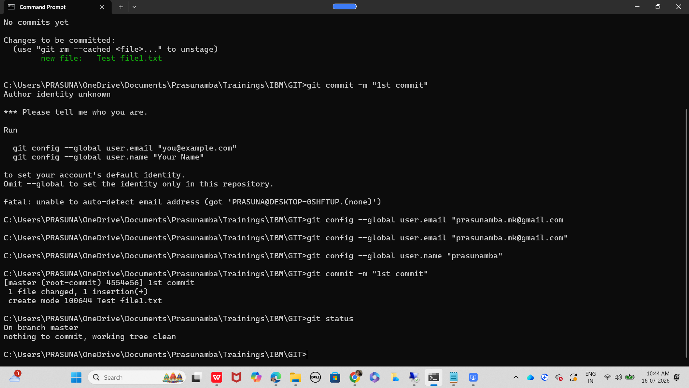

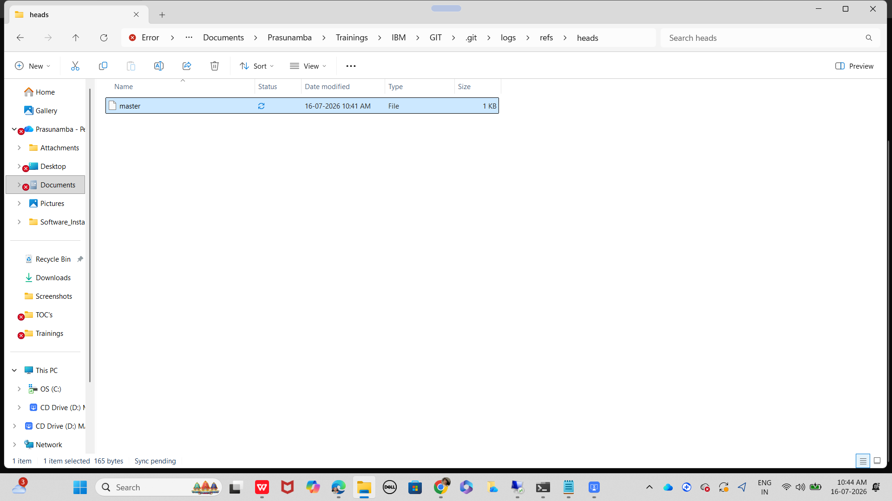

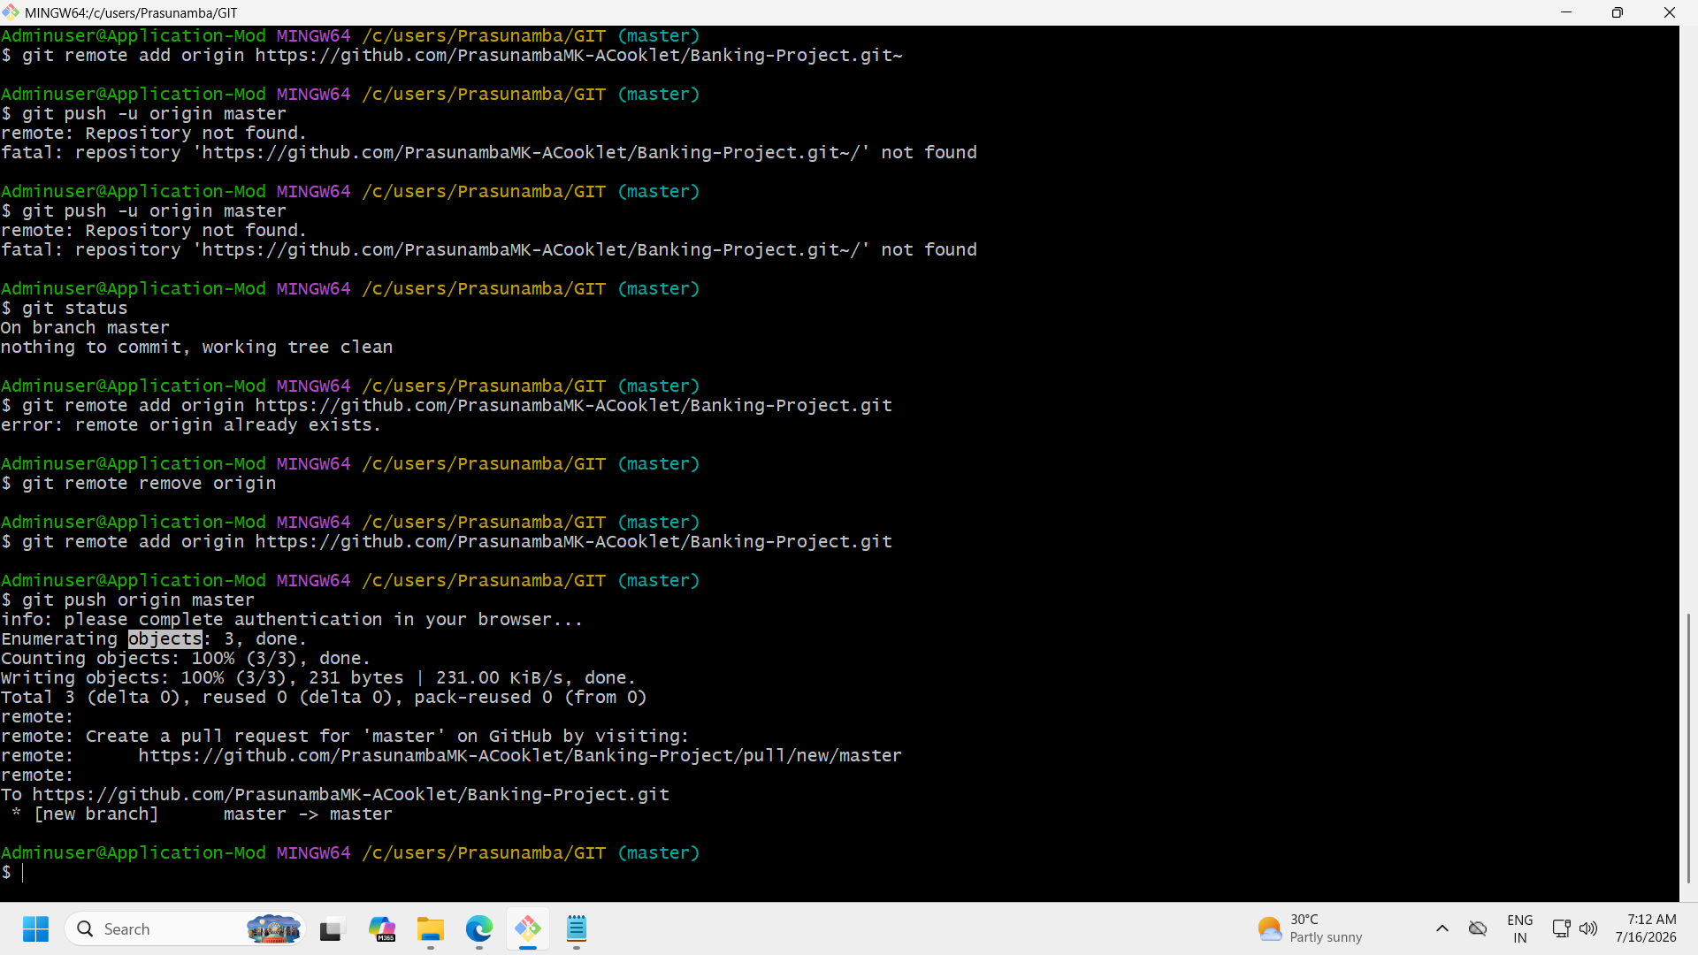

Task 4:
What is the staging area?

2.21 to 2.25

Task 5:
What is vcs?

2.26 to 2.30 to 2.34

Task 6:
What do you understand by fork?

3.59 to 4.03

Commands in cmd:

Create a linux demo directory in your folder using cmd…

Change to the new directory using cmd..

Create a file demo1.txt using echo command in cmd

List all the files in your directory using dir… cmd
Go back to your previous directory — cd..

Go back to your home directory – cd\

Commands in power shell:

Create a shell demo directory in your folder using cmd…

Change to the new directory using cmd..

Create a file demo1.txt using echo command in cmd
Use cat command for reading…

> and >> difference…

List all the files in your directory using dir… cmd
Go back to your previous directory — cd..

Go back to your home directory – cd\

Pavan demo
Sukantho demo

